Table of contents

How to change your default font in Outlook 1
How to add a new signature in Outlook 3

How to change your default font in Outlook

1. Open Outlook
Open Outlook and click on "File" in the navigation menu.
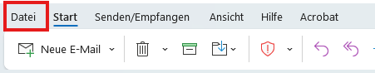

2. Access Options
Click on "Options".

3. Adjust Email Settings
Select "Mail".
Click on "Stationery and Fonts" to choose a font.
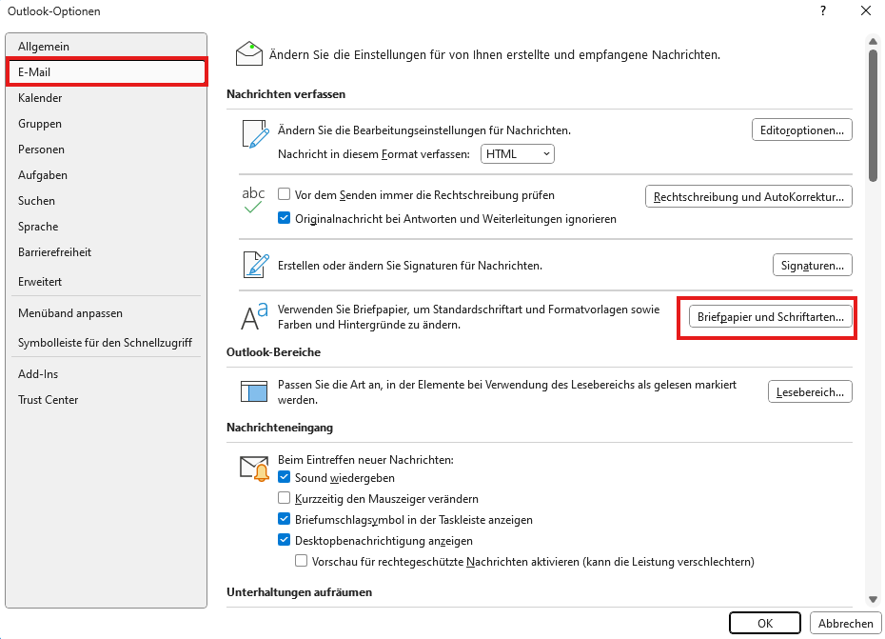

4. Set Default Font for Messages
In both categories:
- "New mail messages"
- "Replying or forwarding messages"
set the font to “Slate Std Thin” (12 pt).
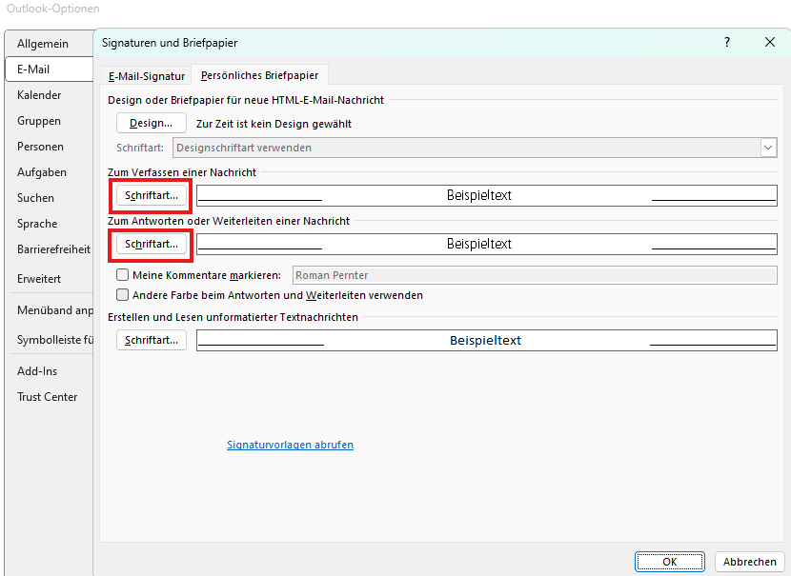
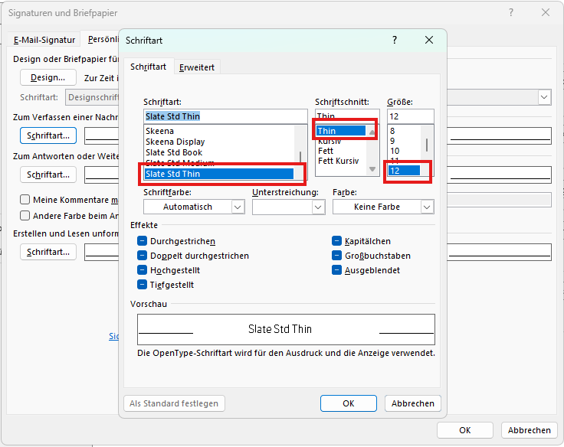

5. Adjust Line Spacing
Go to "Advanced" and set spacing to 0.5.

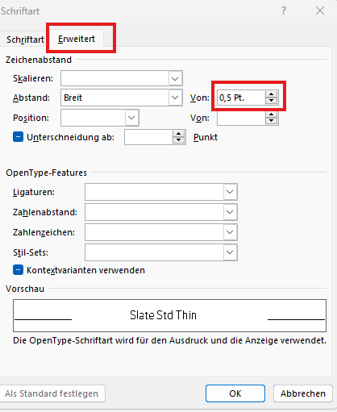

6. Save Changes
Confirm with "OK" and close all Outlook settings windows by pressing "OK".

How to add a new signature in Outlook

1. Open Outlook Signature Settings
- Open Outlook
- Go to File → Options → Mail → Compose Messages → Signatures
2. Create a New Signature
- Click "New" and name your signature.
- Important: Do not modify your default signature; instead, create a new one.

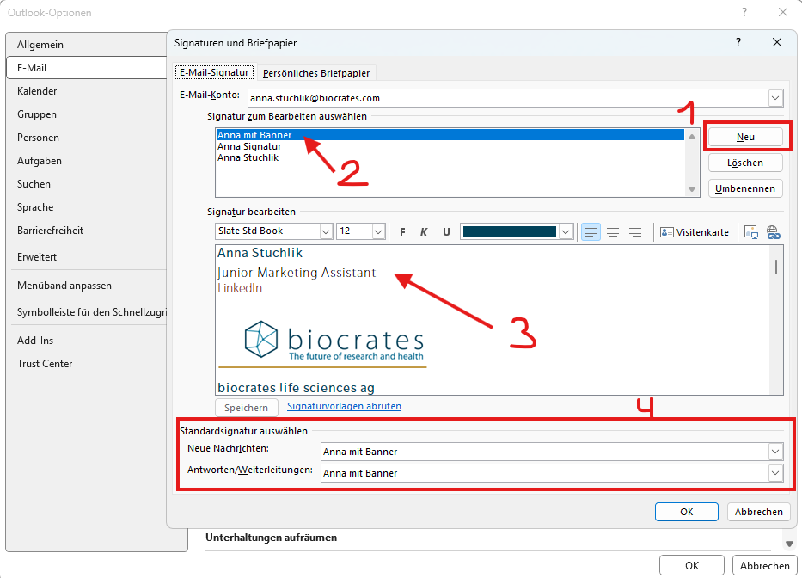

3. Fill in the Signature with Your Details
- Copy the MxP® Quant 1000 Launch Signature below.
- Replace the placeholders with your personal information.
- Paste the customized signature into the editing window in Outlook.

Surname Lastname
Job title (as stated in your job description)
LinkedIn | Book appointment (if applicable)
(BREAK)

biocrates life sciences ag
Eduard-Bodem-Gasse 8 | 6020 Innsbruck | Austria
P +43 512 57 98 23 273 | M add mobile (if applicable)
biocrates.com | LinkedIn | YouTube (Please make sure that the links are not underlined)
(BREAK)

(BREAK)
This message and any attachment thereof are confidential and may be privileged or otherwise protected from disclosure. If you are not the intended recipient any use, distribution, copying or disclosure will be prosecuted. If you have received this message in error, please notify the sender immediately by return e-mail and delete this message and any attachment thereof from your system. Correspondence via e-mail is without obligation and is only for information, unless otherwise agreed in a specific case.

4. Add Links Correctly
- Enter your LinkedIn URL behind "LinkedIn."
- If applicable, add your booking link behind "Book appointment."
- Steps: Right-click on "LinkedIn" → Link → Enter URL → OK. (see screenshots below)
- Ensure that no visible URL appears in the final signature.
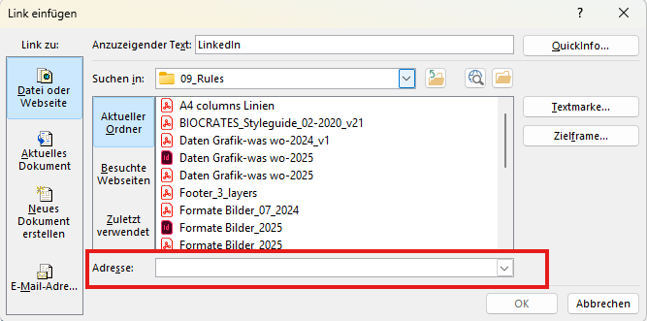
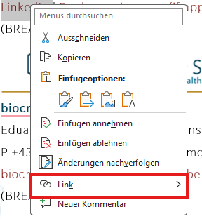

5. Insert the Banner Image Correctly
- Copy the banner image directly from this Word file (the link to the MxP® Quant 1000 landing page is embedded).
- Text below the banner: Font size 10 pt.

6. Check Formatting
- Ensure that the following colors are correct:
- Dark blue (#00425a) for text. (see screenshots below)
- Red (#8d2f28) for links.
- The links should not be underlined.
- Check that your new signature is selected for "New Messages" and "Replies/Forwards."
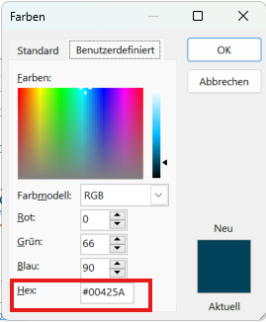
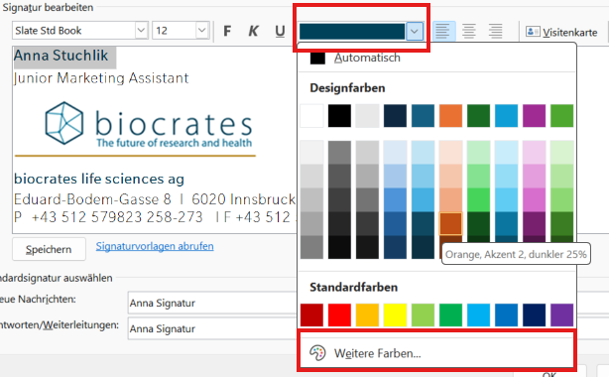

7. Save and Activate
- Confirm everything by clicking "OK."
- After the MxP® Quant 1000 launch, you may switch back to your default signature.

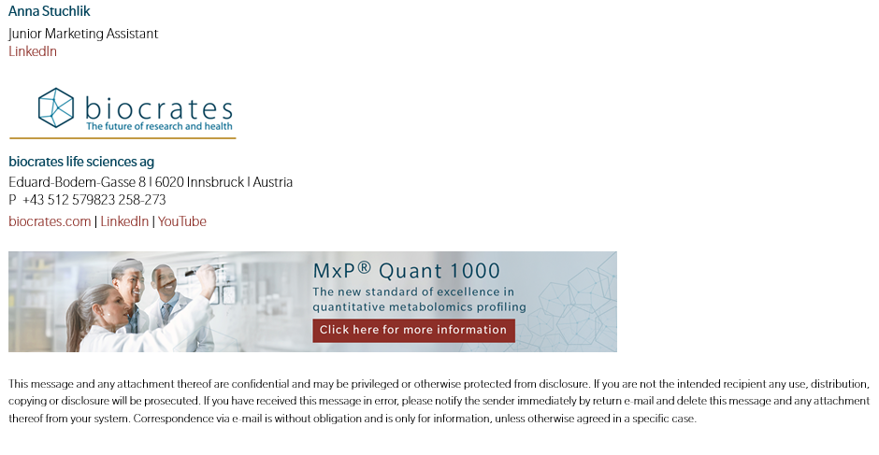
Example of a correct MxP® Quant 1000 launch signature.

